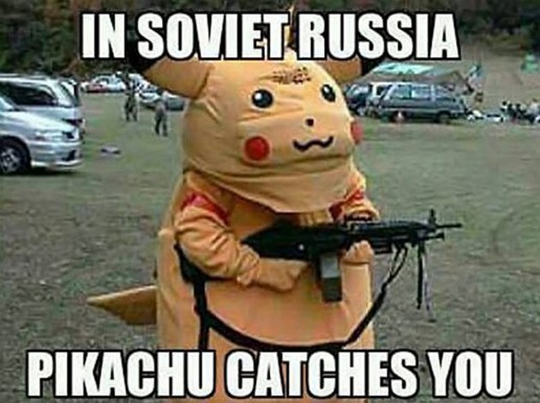

| Los 龔 PIKTUBHU (PITCHES WOU